# Employee Management System Planning Document

## General Description

In the current employee management system, admin adds new regulations and assigns them to the department manually. Department Head sends these regulations to the individual users through mail to get their consent. Users send their comments through the courier service after reading regulations. Department head has to collect the user inputs and pass them on to Admin. Since a lot of manual workflow is involved, it is time consuming for admin to close each regulation. So, a new system is required to automate this regulation creation creation and closure process.

## UI Screen planning

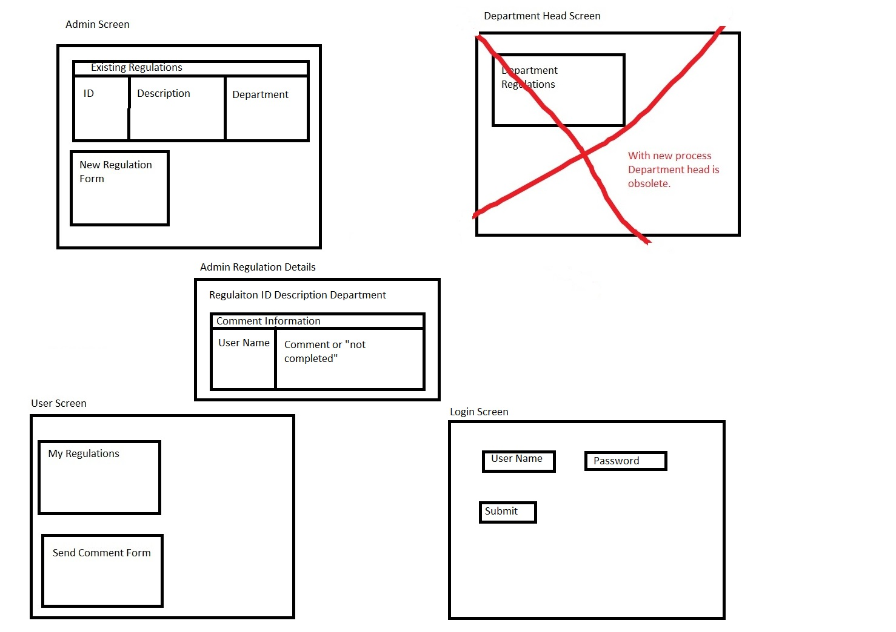

## ER Diagram

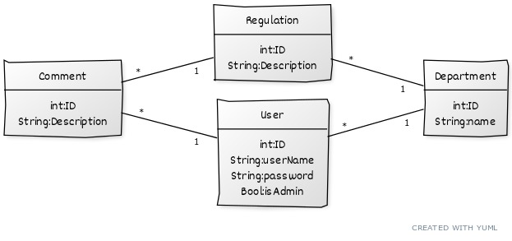

## Interaction Planning

|  |  |  |
| --- | --- | --- |
| Initial State | User Action | Response |
| At login screen | Incorrect user password | Back to login screen with error message |
| At login screen | Correct User password | To User screen session set to userID |
| At login screen | Correct Admin password | To Admin screen |
| At admin screen | Submit regulation | Add to database back to admin screen |
| Any screen | Request fails validation | Invalidate session back to login |
| At admin screen | Select existing regulation | To admin regulation details |
| At admin regulation details | Hit home button | To admin screen |
| At user screen | Select regulation | Update Comment Form |
| At user screen | Submit comment | Add to or update database |
|  |  |  |